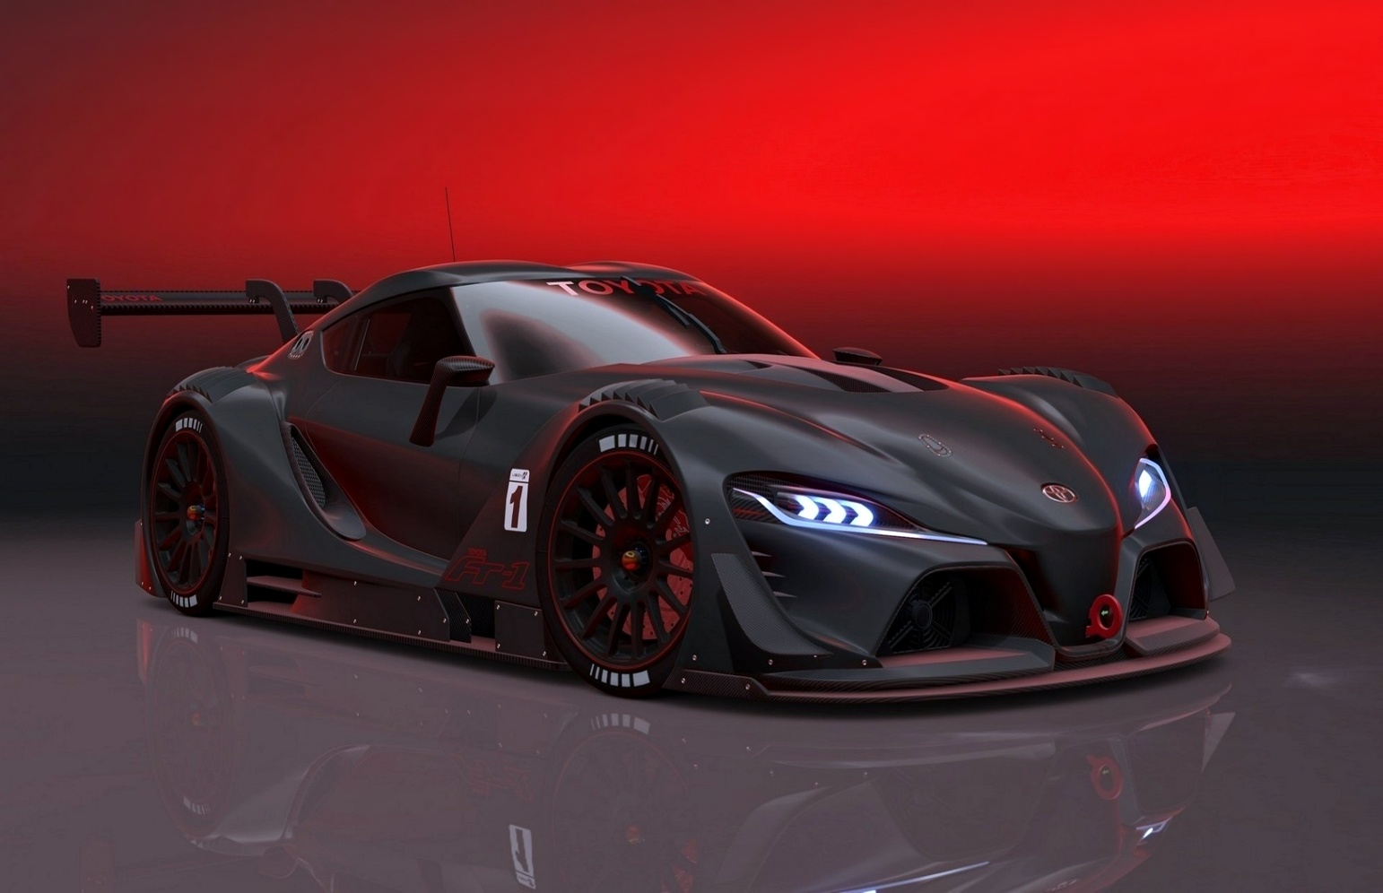

# **Car Sales Analysis**

***February 2025***

**Presented By**

**Shivanand S Nashi**

**INTRODUCTION:**

The Car Sales Dashboard was developed in Power BI to provide a comprehensive overview of sales performance for a car dealership. This dynamic and interactive dashboard enables stakeholders to track key performance indicators (KPIs), identify trends, and make data-driven decisions. The project was structured into various phases, including data import, modeling, DAX formula creation, visualization, and optimization.

**PROJECT BACKGROUND:**

The project is centred around the critical analysis of a car dealership. The report evaluates the development and implementation of a Power BI Car Sales Dashboard for the same. The dashboard aims to optimize sales performance tracking and enable data-driven decision-making.

**PROBLEM STATEMENT:**

**BACKGROUND:**

Limited visibility into real-time sales performance makes it difficult for dealerships and manufacturers to make timely decisions regarding inventory, pricing, and marketing strategies.

**OBJECTIVE:** Develop a Power BI dashboard to monitor and analyse key car sales metrics, offering clear insights into sales trends, inventory turnover, and customer purchasing behavior.

**SCOPE:**

The dashboard will focus on:

* + Total car sales and revenue analysis
  + Brand and model performance tracking
  + Regional and dealership-wise sales comparison
  + Customer preferences and demographic insights
  + Inventory vs. sales analysis

**PROJECT OBJECTIVE:**

The objective of this project is to design and develop a dynamic and interactive Car Sales Dashboard using Power BI that enables the efficient tracking and evaluation of sales data. By leveraging the power of data visualization, the dashboard empowers decision-makers to make informed choices with the help of some critical KPIs related to car sales, optimize inventory management, and ultimately drive business growth within the automotive industry.

**DATA OVERVIEW :**

The data modelled in the project is of a 2 years span (i.e., 2022 and 2023). It consists of 23907 rows and 16 columns. There are various columns like Car Id, Date, Customer Name, Gender, Annual Income, Dealer Name, Company, Model, Engine, Transmission, Colour, Price, Dealer Number, Body Style, Phone and Dealer Region. Car ID column is a column with unique and non-null values.

# **NUMERICAL KEY PERFORMANCE INDICATORS (KPIS)**

**Sales Overview:**

1. Year to Date (YTD) Total Sales- YTD total sales gives insights into the current/latest year sales. In this case, the latest year is 2023, so the total sales for 2023 is $371.2M.

**DAX Function:**

**YTD Total Sales= TOTALYTD(SUM(car_data[Price ($)]),'Calender Table'[Date])**

**Output:**

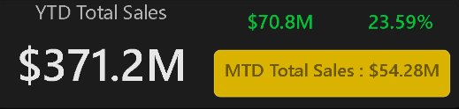

**2.Year on Year (YOY) growth-** YOY growth percentage calculates the percentage comparing previous year sales and current year sales. Revenue increased by 24%.

**DAX Function:**

**[YOY Sales growth]= [Sales Difference] / [PYTD Total Sales]**

[Sales Difference]= [YTD Total Sales]-[PYTD Total Sales]

[PYTD Total Sales]= CALCULATE(SUM(car_data[Price ($)]),SAMEPERIODLASTYEAR('Calender Table'[Date]))

**Output:**

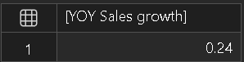

**Average Price Analysis :**

**1.Year to Date (YTD) Average Price-** This KPI will give us the current year’s average price which is calculated using the YTD Total Sales Amount and YTD Number of Car sales metrics.

**DAX Function:**  [YTD Avg Price]= TOTALYTD([Avg price], 'Calender Table'[Date])

**Output:**

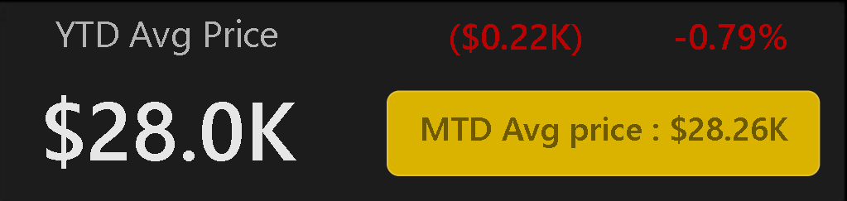

**2.Year on Year (YOY) Average price growth-** This identifies the variations between the last and current years’ Average Prices in the form of percentage.

**DAX Function:**  YOY Avg Price Growth = [Avg Price Diff] / [PYTD Avg Price]

**[Avg Price Diff] = [YTD Avg Price] - [PYTD Avg Price]**

**[PYTD Avg Price] = CALCULATE([Avg price], SAMEPERIODLASTYEAR('Calender Table'[Date]))**

**Output:**

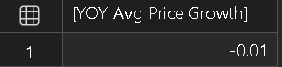

**Cars Sold Metrics :**

**1.Year to Date (YTD) Cars Sold-** The number of cars sold in the latest year (2022).

**DAX Function:**  [YTD Cars Sold] = TOTALYTD(COUNT(car_data[Car_id]), 'Calender Table'[Date])

**Output:**

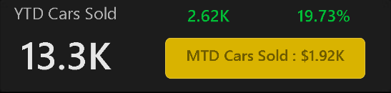

2.Year on Year (YOY) Cars Sold Growth-This gives the growth percentage of the cars sold between the previous and the latest year.

**DAX Function:**  [YOY Cars Sold Growth] = [Cars Sold Diff] / [YTD Cars Sold]

[Cars Sold Diff] = [YTD Cars Sold] - [PYTD Cars Sold]

[PYTD Total Sales] = CALCULATE(SUM(car_data[Price ($)]),SAMEPERIODLASTYEAR('Calender Table'[Date]))

**Output:**

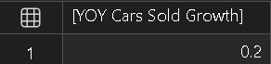

**GRAPHICAL REPRESENTATIONS OF SOME OTHER KPIS**

**1.Weekly Sales Trend:** The Line chart reveals weekly fluctuations and potential seasonality.

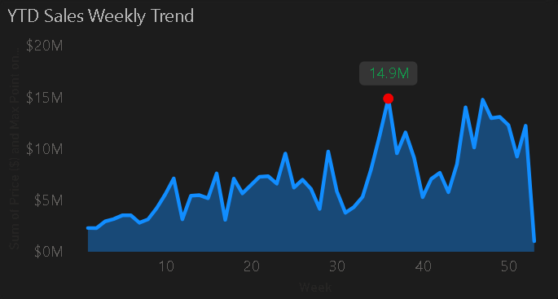

**Inference:** The highest sales is observed to be in the 50th week($28M). There is usually an upward trend of sales in all the weeks except Week 40th-41st. In the 40th week($13M), the sales almost dipped by half as of the previous week($26M) and that came even down in the 41st week($9M).

**2.Body Style Sales:** Pie chart shows which styles are driving the market.

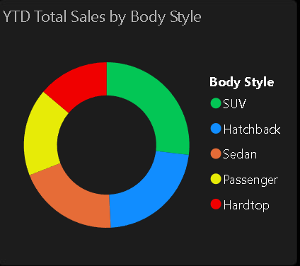

**Inference:** SUVs and Hatchbacks led sales with 25.41% and 24.75% market share, respectively. There still seems to be a good potential to improvise our Passenger (17%) and Hardtop (12.9%) category.

**3.Total Sales by Color:** Analyses popular car colours and identifies the customer buying trends.

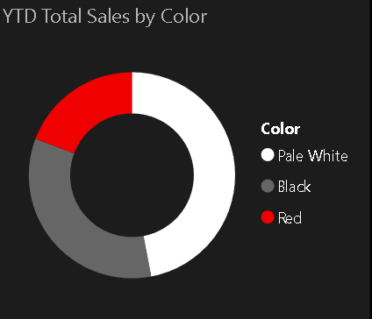

**Inference:** ‘Pale White’ seems to be the most preferred choice of the customers (46%), that is **almost half the customers** are going for this color. The least preferred is ‘Red color’ .

**4.YTD Cars Sold by Dealer_Region:** A Map Chart visualizes YTD Cars Sold by Dealer Region, highlighting sales performance across different geographic areas using size and color intensity.

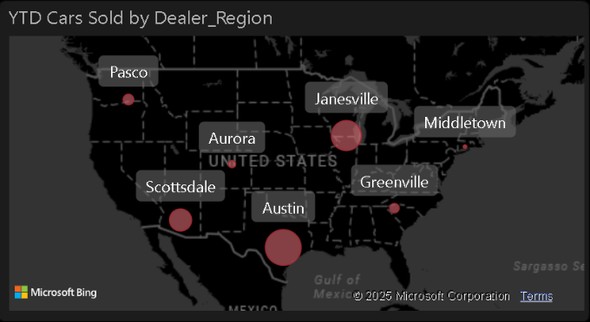

**Inference:**

1. **Austin is the Leading Region** – The **largest bubble** indicates that Austin has the **highest car sales YTD** among the dealer regions.
2. **Janesville is a Strong Market** – A **significant-sized bubble** suggests that Janesville also has high car sales, though lower than Austin.
3. **Smaller Markets Exist** – Regions like **Pasco, Aurora, Greenville, and Middletown** have relatively smaller bubbles, indicating **lower sales volume**.
4. **Regional Sales Distribution** – Sales are spread across various states, with **higher concentration in the South (Austin, Scottsdale) and Midwest (Janesville, Aurora)**.
5. **Potential Growth Areas** – Smaller regions like **Pasco and Greenville** could be opportunities for growth or indicate lower market demand.

**5. Company-Wise Sales Trend in Grid Form:** A Grid Chart displays the Company-Wise Sales Trend in a structured table format, showing sales figures across different time periods. It allows for easy comparison of sales performance by company, helping identify trends and market leaders.

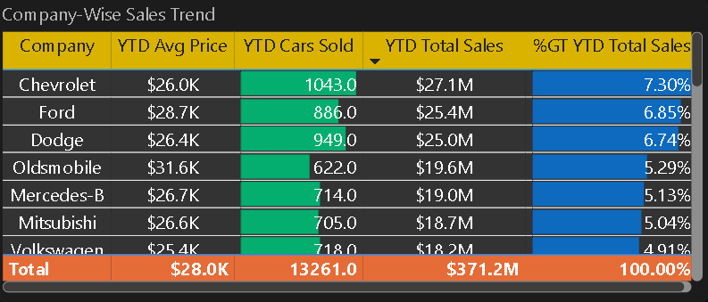

**Inference:**

1. Chevrolet Leads the Market – With 1,043 cars sold, Chevrolet holds the highest YTD total sales of $27.1M, contributing 7.3% to the total market sales.
2. Ford & Dodge Follow Closely – Ford and Dodge have similar YTD total sales of $25.4M and $25.0M, contributing 6.85% and 6.74%, respectively.
3. Oldsmobile Has the Highest Avg Price – At $31.6K per vehicle, Oldsmobile leads in pricing but has fewer sales (622 units).
4. Market Concentration – The top three companies (Chevrolet, Ford, and Dodge) account for a significant portion of the market, showing a competitive edge.
5. Total Market Performance – A total of 13,261 cars were sold, generating $371.2M in sales, with Mitsubishi, Mercedes-B, and Volkswagen contributing modest shares (~5% each).

**6.Details Grid Showing All Car Sales Information:** A Details Grid chart provides a structured table view of all car sales information, allowing for easy comparison and analysis.

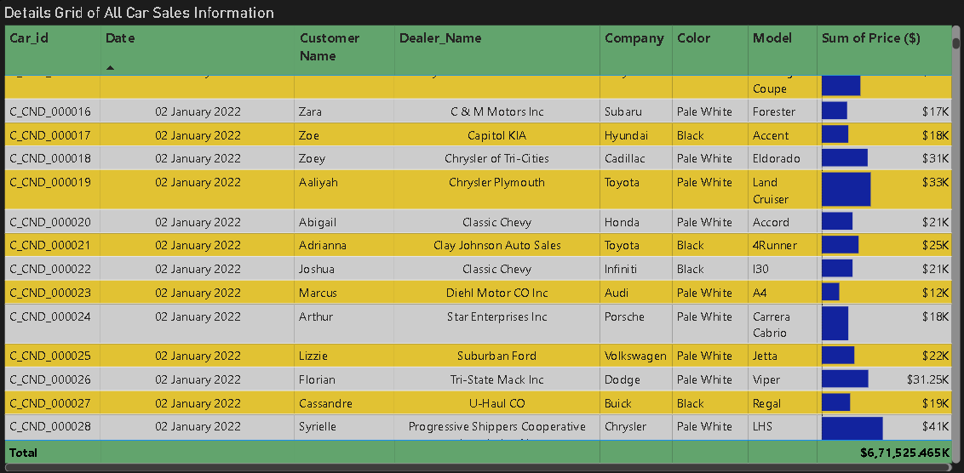

**Inference:**

1. Varied Car Models & Prices – The grid shows different car models like Forester, Accent, Eldorado, Land Cruiser, and Viper, with prices ranging from $12K to $41K.
2. Toyota & Cadillac Among Top Sellers – High-priced models like the Toyota Land Cruiser ($33K) and Cadillac Eldorado ($31K) contribute significantly to total sales.
3. Pale White is a Popular Car Color – Many vehicles sold are Pale White, suggesting customer preference or dealer stock dominance.
4. Dealer-Wise Sales Distribution – Various dealerships such as C&M Motors Inc, Capitol KIA, Classic Chevy, and Suburban Ford are handling sales, showing a diverse dealership network.
5. Total Sales Value – The cumulative sales amount reaches $6,71,525.465K, indicating a high transaction volume.
6. Graphical Sales Representation – The Sum of Price ($) column includes bar visuals, making it easy to compare sales values across different cars.

# **POWER BI DASHBOARDS:**

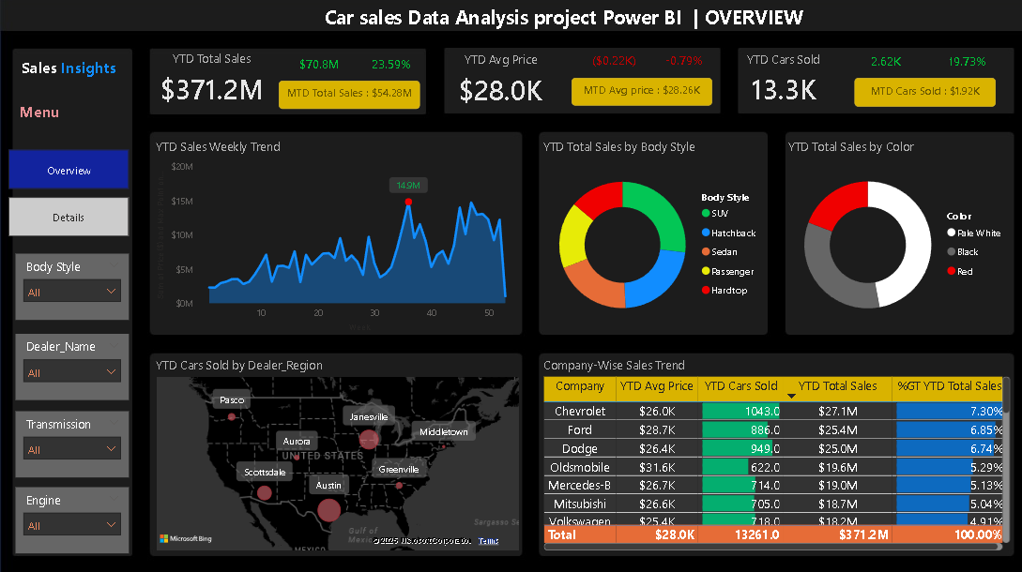

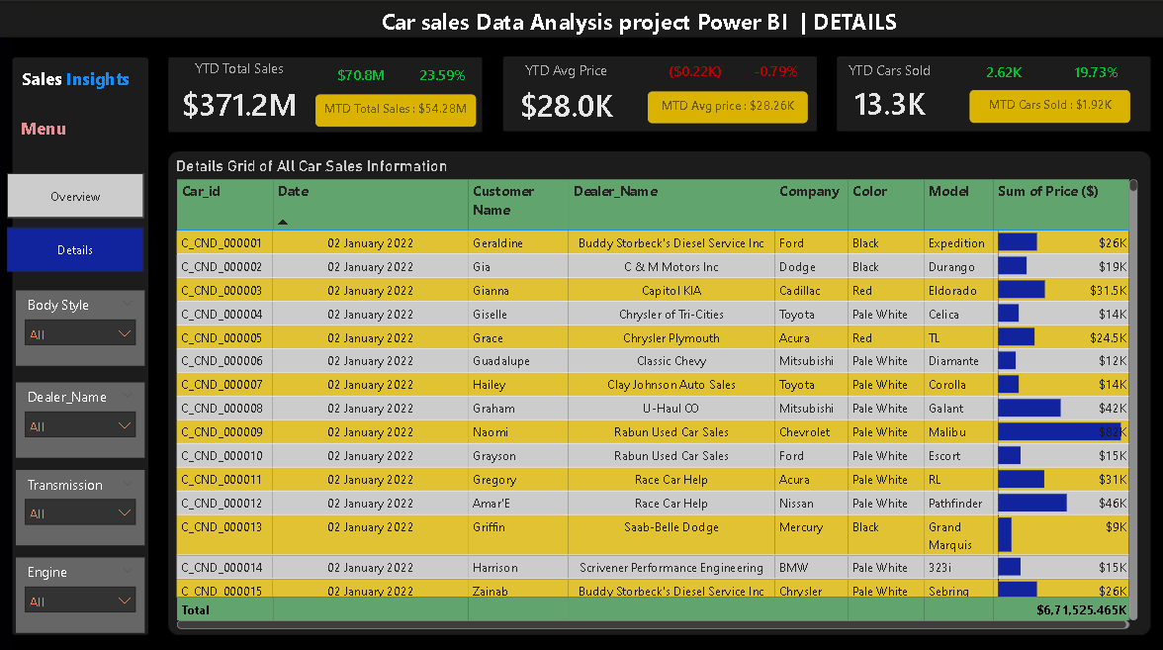

The dashboard has a separate filter panel on the bases of 4 different categories. The client can easily drill down and refine the data for the desired results in order to get insights into the data.

**BUSINESS INSIGHTS DRAWN FROM THE DATA**

1. **Sales Performance Trends:**
   * The total YTD sales for 2023 amounted to $371.2M, reflecting a 24% increase from the previous year.
   * The highest weekly sales were observed in the 50th week ($28M), with a significant drop in weeks 40 and 41, highlighting potential seasonal trends or market fluctuations.
2. **Brand & Model Performance:**
   * Chevrolet leads the market with 1,043 units sold, generating $27.1M, followed by Ford ($25.4M) and Dodge ($25.0M).
   * Oldsmobile has the highest average price per vehicle ($31.6K), though it has fewer total sales (622 units).
   * Toyota and Cadillac are among the top-selling brands, with models like the Toyota Land Cruiser ($33K) contributing significantly to total revenue.
3. **Customer Preferences:**
   * SUVs (25.41%) and Hatchbacks (24.75%) dominate sales, indicating high consumer demand.
   * Passenger and Hardtop cars have lower market shares (17% and 12.9%, respectively), presenting opportunities for growth.
   * Pale White is the most preferred car color (46% of total sales), while Red is the least popular.
4. **Regional Sales Insights:**
   * Austin has the highest YTD car sales, making it the strongest regional market.
   * Janesville is another key market with significant sales, while smaller markets like Pasco, Aurora, and Greenville show lower sales volumes.
   * The Southern and Midwestern regions have higher sales concentration, suggesting strong market demand in these areas.
5. **Inventory vs. Sales Analysis:**
   * High sales in specific models and brands indicate the need for better stock management and forecasting to meet consumer demand.
   * Inventory turnover insights suggest that brands with lower sales may require targeted marketing strategies to boost performance.
6. **Revenue & Pricing Trends:**
   * The YOY growth in average car prices suggests a favourable pricing strategy or increased demand for higher-priced models.
   * Competitive pricing strategies may be required for brands with lower sales to enhance market penetration.

**CONCLUSION:**

The Car Sales Dashboard developed in Power BI provides actionable insights that empower dealerships and manufacturers to make data-driven decisions. By analysing sales trends, customer preferences, and regional performance, businesses can optimize their inventory management, enhance marketing strategies, and drive overall growth. The findings indicate strong market demand for SUVs and Hatchbacks, with Chevrolet, Ford, and Dodge leading sales. Regional insights highlight Austin and Janesville as key markets, while emerging markets like Pasco and Greenville offer growth opportunities.

Moving forward, dealerships can leverage these insights to improve stock forecasting, tailor promotional campaigns, and refine pricing strategies, ultimately driving higher sales and profitability.